Create Comprehensive Dashboards

Overview

This guide walks you through creating a comprehensive monitoring dashboard in Grafana using Prometheus as the data source on an Ubuntu system.
You will learn how to start the Grafana server, connect it to Prometheus, and visualize system performance metrics such as CPU usage, memory utilization, and disk usage using PromQL queries. By the end, you will have a fully functional, real-time dashboard for infrastructure monitoring.

Prerequisites

- Ubuntu OS
- Grafana installed
- Prometheus installed
- Basic knowledge of PromQL

Step 1 – Open Grafana in Ubuntu

- Open Ubuntu

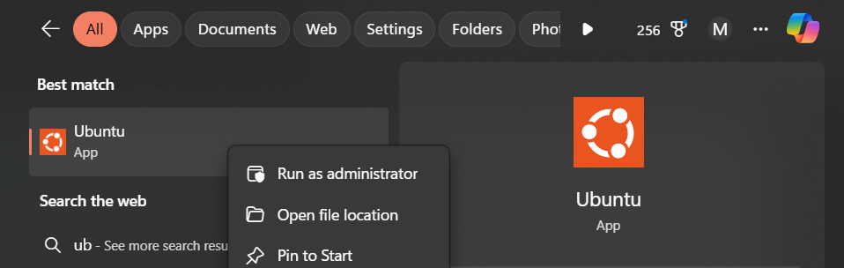

- Enter the following command to run the Grafana:
  - sudo systemctl start grafana-server

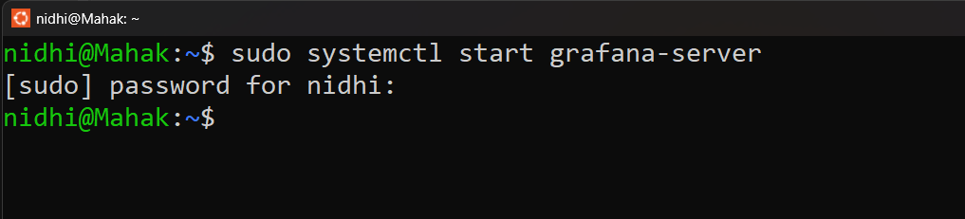

- By default, Grafana runs on port 3000.
- Open your browser and go to:
  - http://localhost:3000
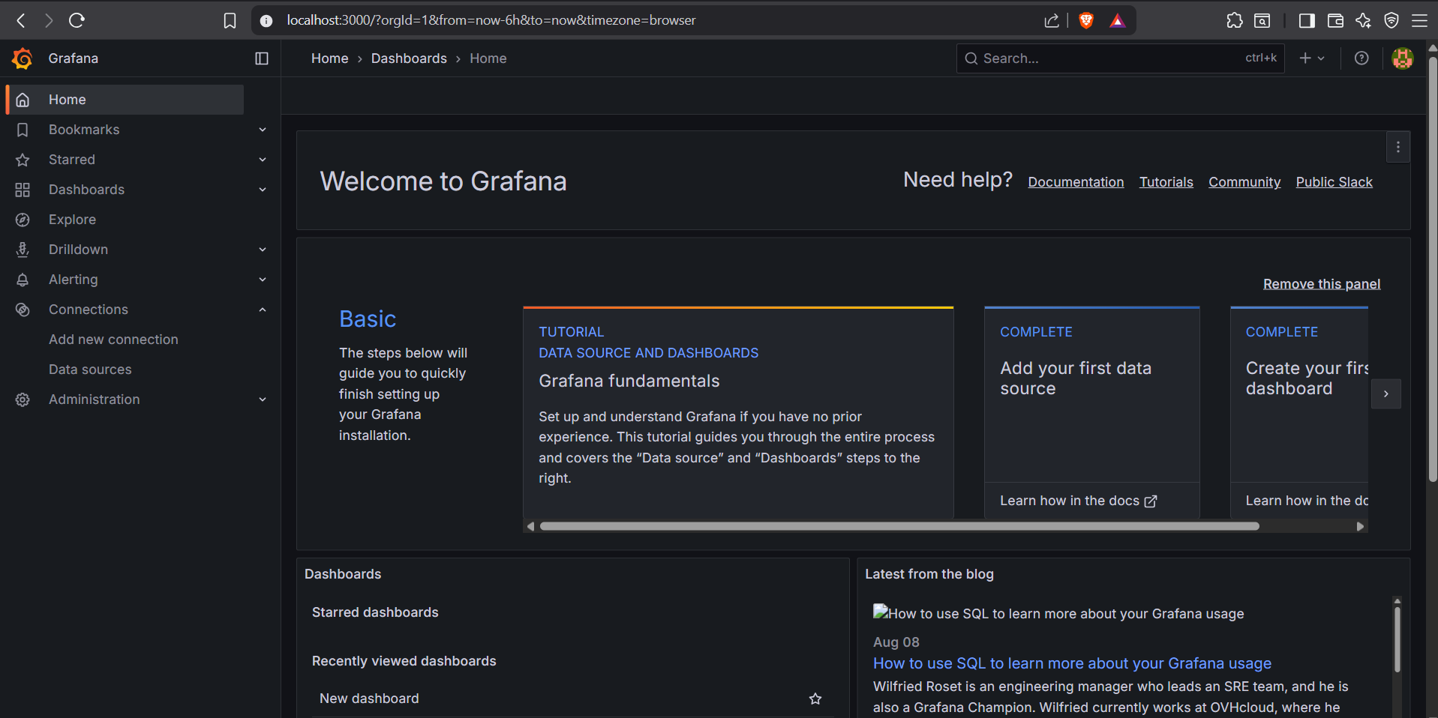

Step 2: Create a New Dashboard
- From the left sidebar, click Dashboards → New → New Dashboard.

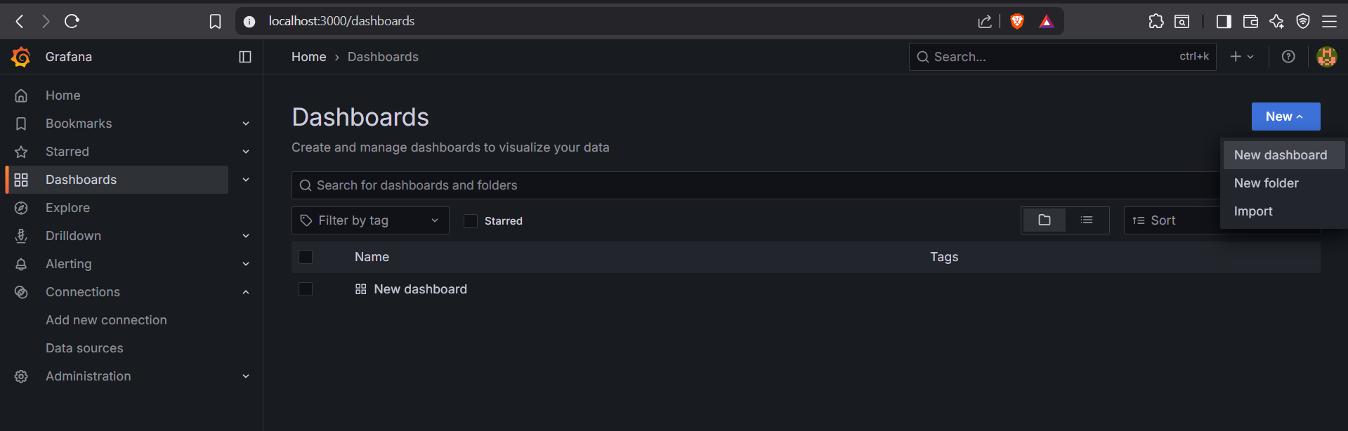

- Click Add visualization.

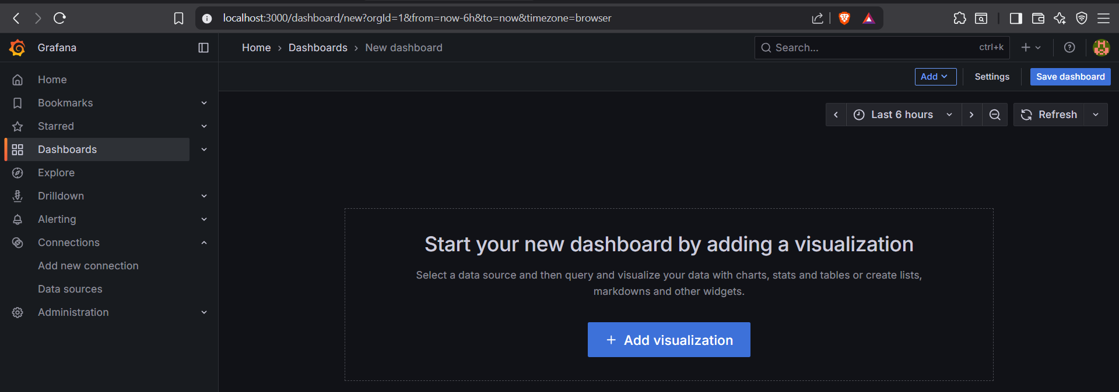

Step 3 – Add Prometheus as Data Source

- Go to Data source Select Prometheus.

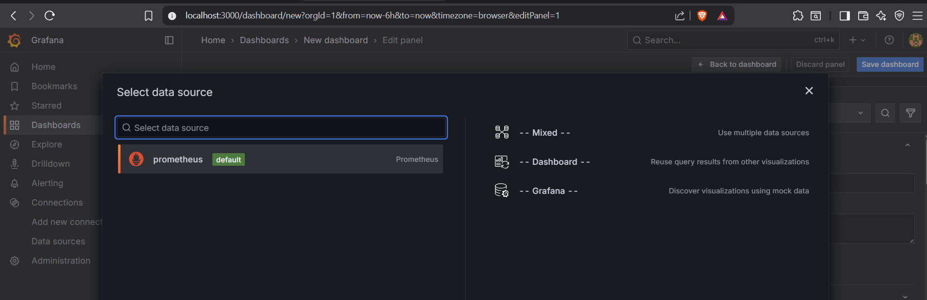

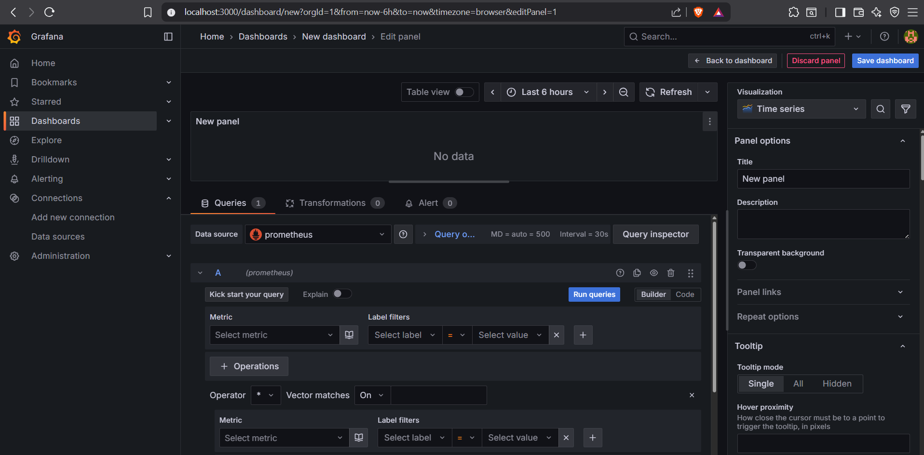

Step 4 – Write a PromQL Query for Your First Panel

- Example: CPU usage % per instance

(In the panel editor, choose your Prometheus data source.)
- Go to code Enter this PromQL:

100 * (1 - avg by(instance) (irate(node_cpu_seconds_total{mode="idle"}[5m])))

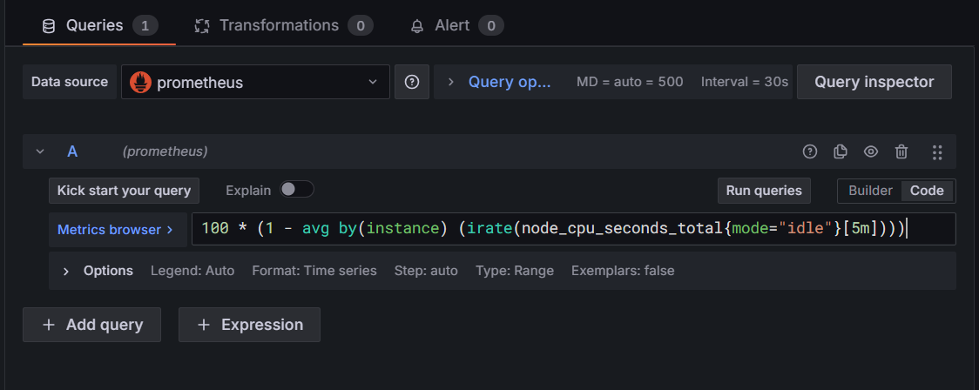

- Change Visualization to Time series.

Under Panel options, set:
Unit = percent (0-100)
Min = 0
Max = 100

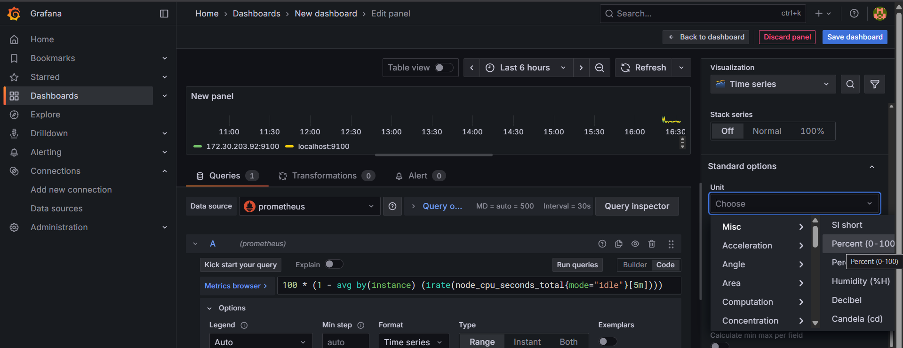

You can see the time series

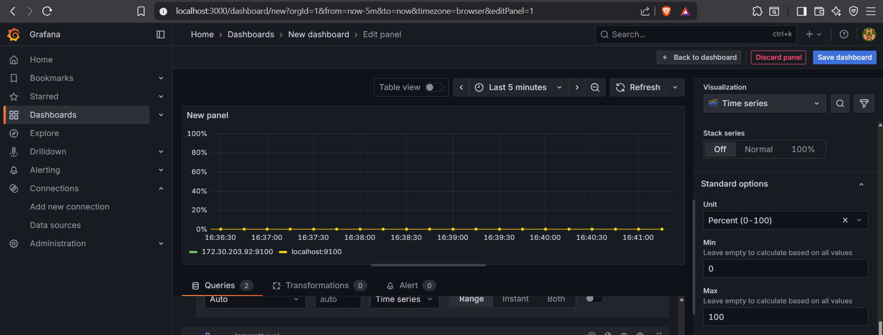

Step 4 – Add More Panels for Key Metrics

Repeat Step 3 for each metric you want.
Here are some ready-to-use queries:

- Memory usage %

(1 - (node_memory_MemAvailable_bytes / node_memory_MemTotal_bytes)) * 100

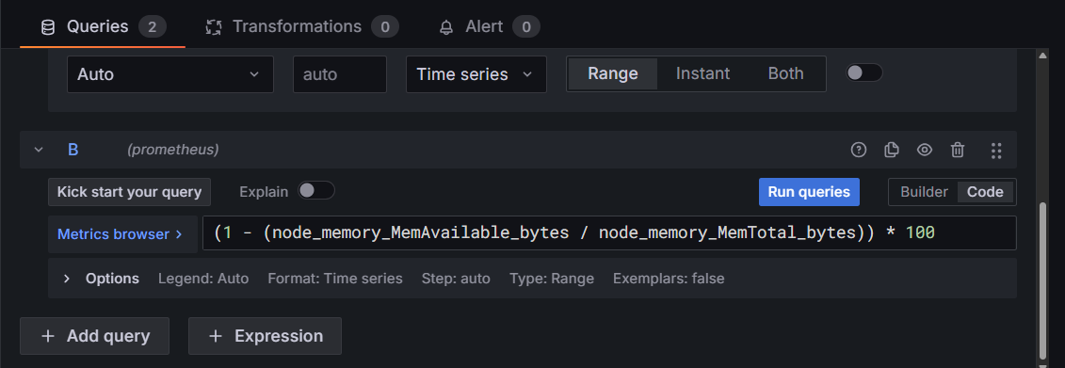

- Click on run queries
- See the output in new panel

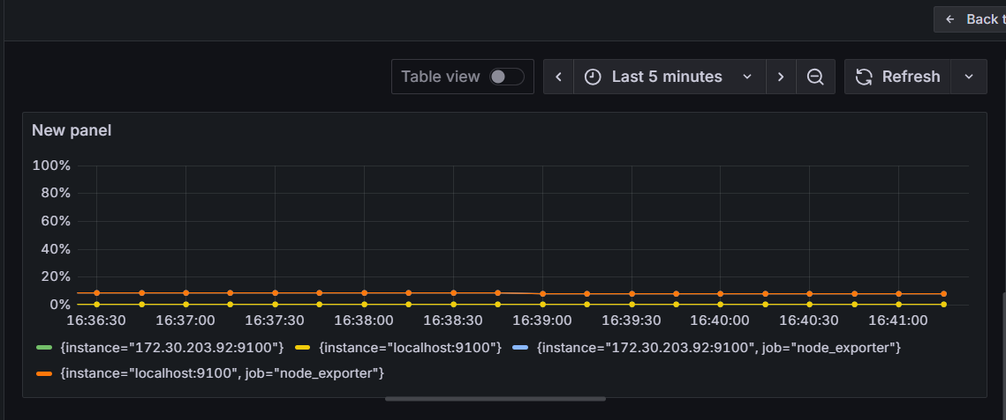

- Disk usage %

((node_filesystem_size_bytes{fstype!~"tmpfs|overlay"} - node_filesystem_free_bytes{fstype!~"tmpfs|overlay"})
/ node_filesystem_size_bytes{fstype!~"tmpfs|overlay"}) * 100

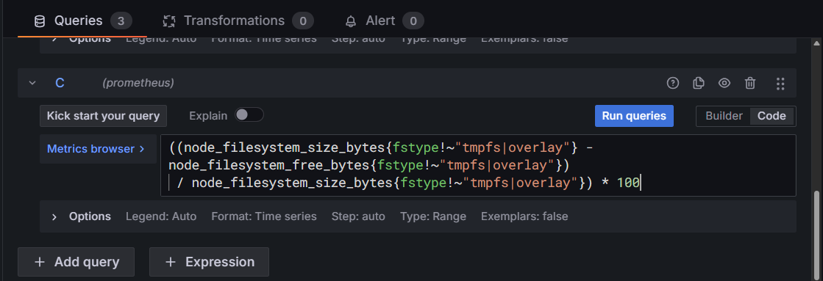

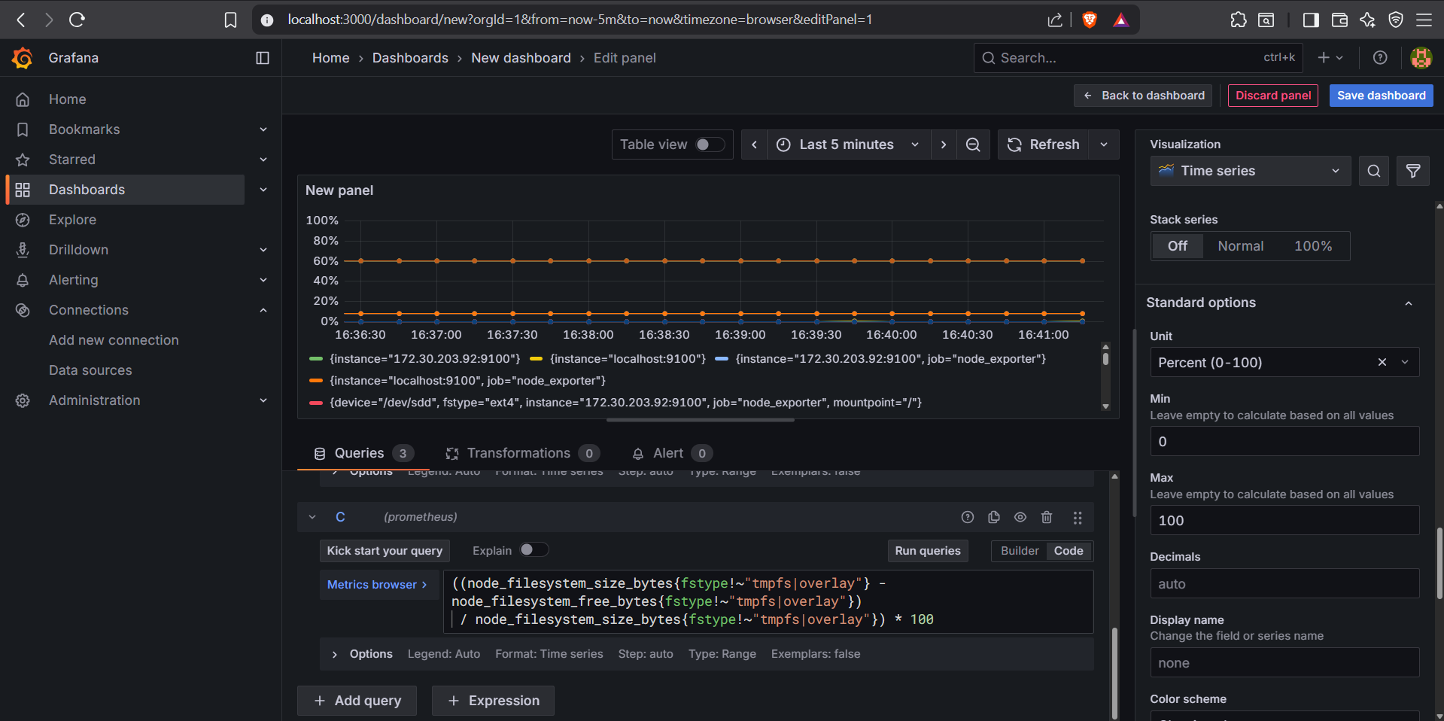

- Save the Dashboard.

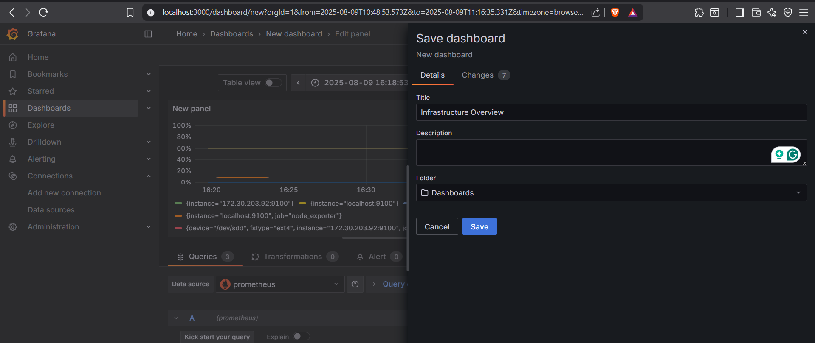

- Dashboard successfully created.

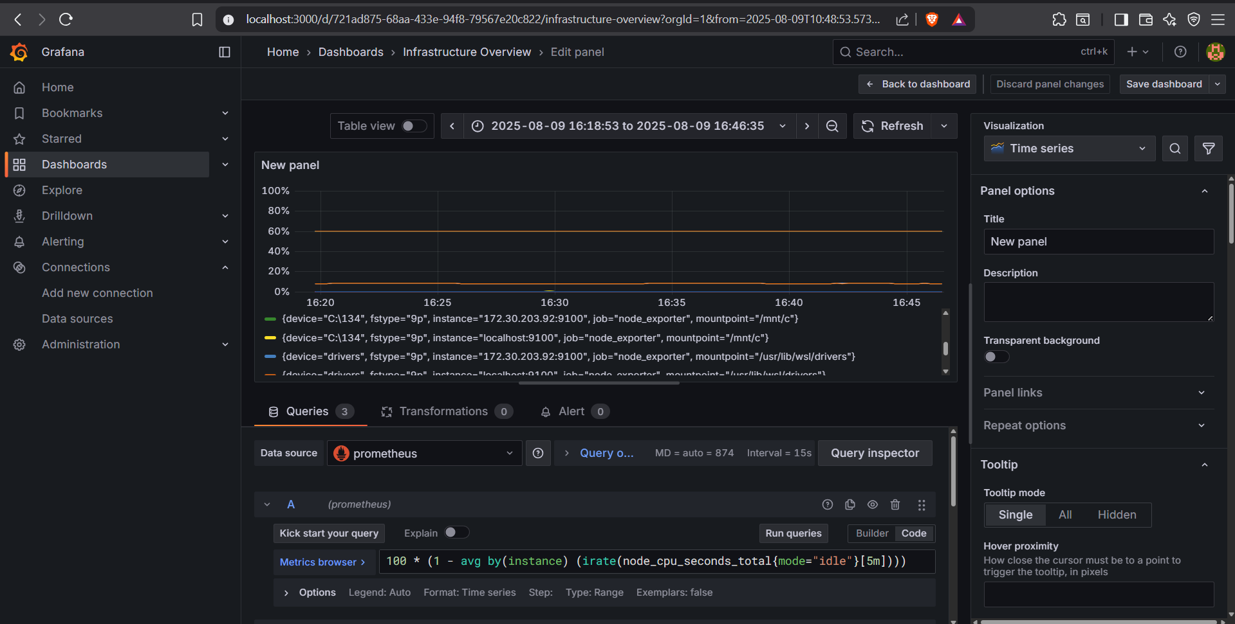

Conclusion
By following this process, we have successfully set up a Grafana dashboard on Ubuntu, connected it to Prometheus, and visualized essential system metrics including CPU, memory, and disk usage. Using targeted PromQL queries and optimized visual settings, the dashboard now provides clear, real-time insights into system performance. This setup ensures efficient monitoring, faster issue detection, and a strong foundation for expanding the dashboard with additional metrics and custom visualizations as needed.

